Week 8 - S8 - Core OOP - Abstract Class And Interface - Lab Problem

**Name:**Ramesh Harisabapathi Chettiar

**Date of Submission:**07/10/25

**QNO1🡪**

Create an abstract class Fruit with protected fields color and taste. Add an abstract

method showDetails().

Create an interface Edible with method nutrientsInfo().

Create a class Apple that extends Fruit and implements Edible, adding a variety field.

Hints:

● Use abstract for parent class.

● Use interface for common behavior.

● Implement both abstract and interface methods.

Fruit.java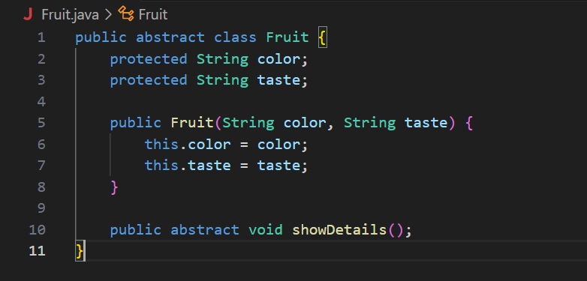

Edible.java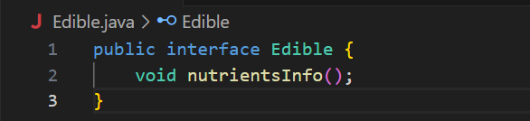

Apple.java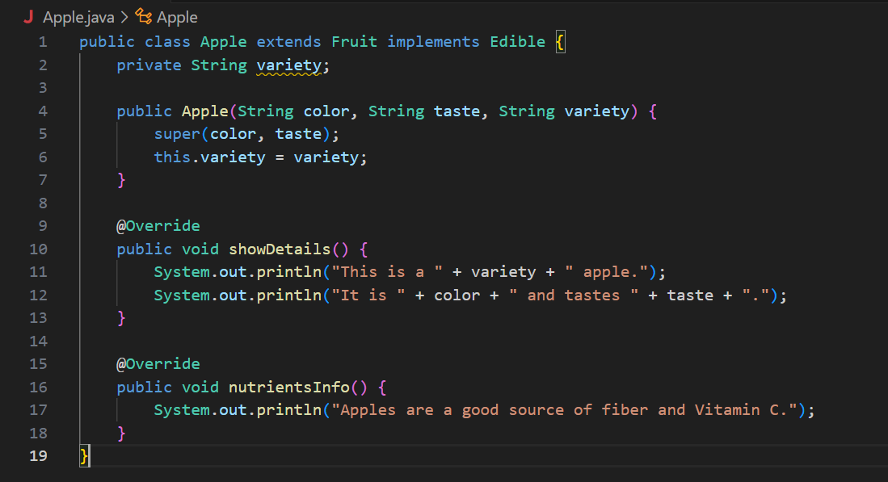

Main.java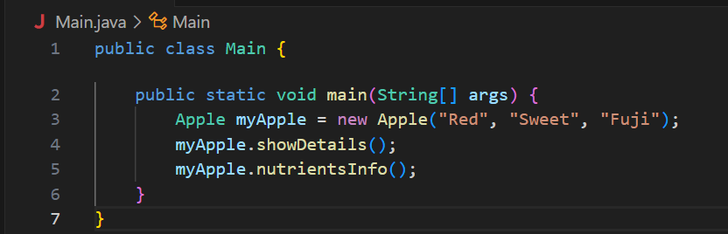

OUTPUT🡪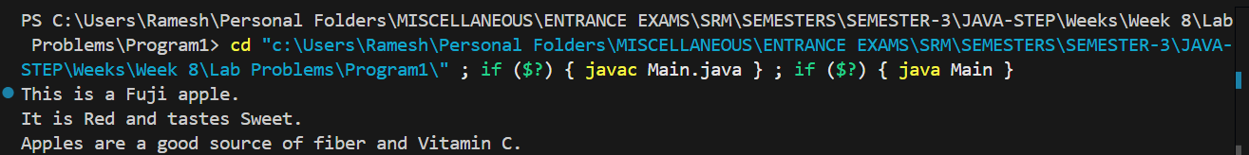

QNO2🡪

Create an abstract class Shape with fields area and perimeter. Add abstract methods

calculateArea() and calculatePerimeter().

Create an interface Drawable with method draw().

Create a class Circle extending Shape and implementing Drawable.

Hints:

● Abstract methods must be overridden in child class.

● Use interface to add extra behavior.

Drawable.java

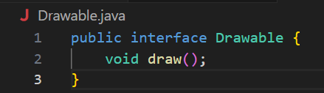

Shape.java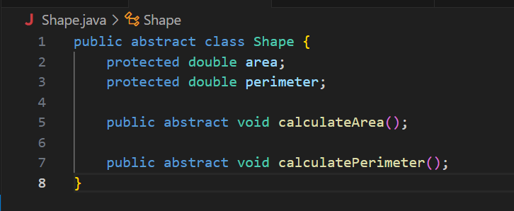

Circle.java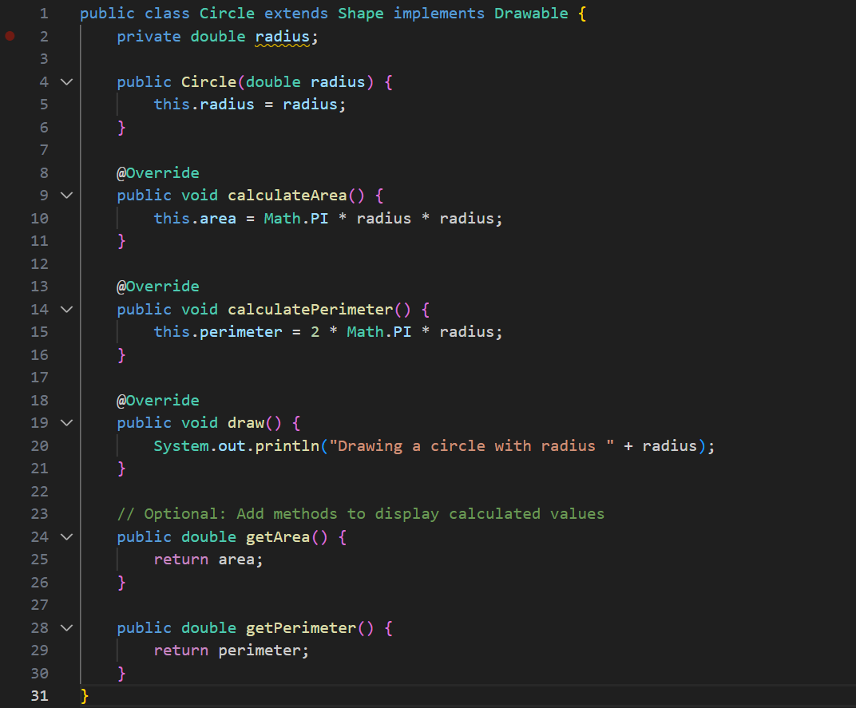

Main.java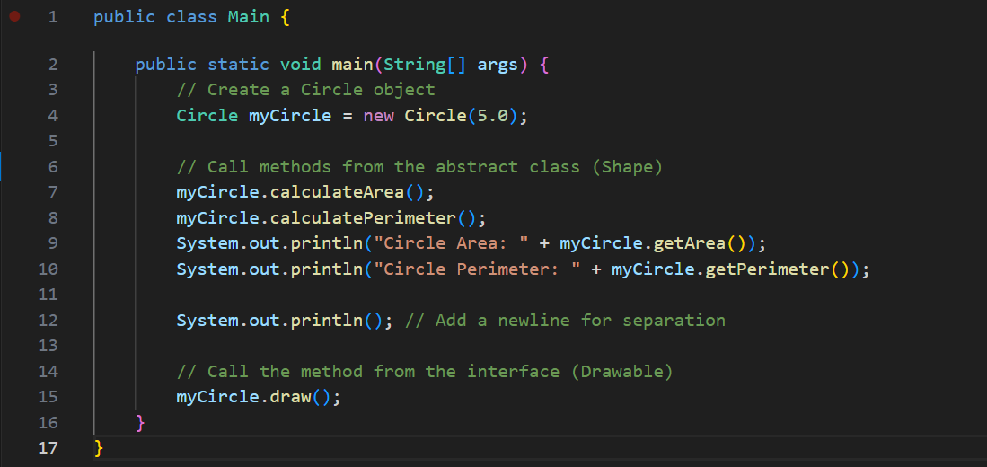

**OUTPUT🡪**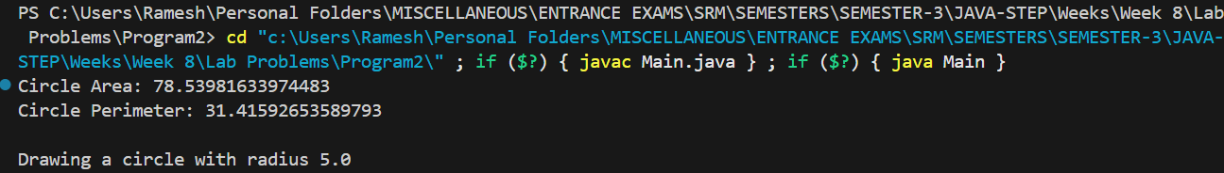

**QNO3🡪**

Create an abstract class Vehicle with protected fields speed and fuelType. Add an abstract

method startEngine().

Create an interface Maintainable with method serviceInfo().

Create a class Car that extends Vehicle and implements Maintainable.

Hints:

● Use extends and implements together.

● Provide concrete implementations for abstract and interface methods.

Maintainable.java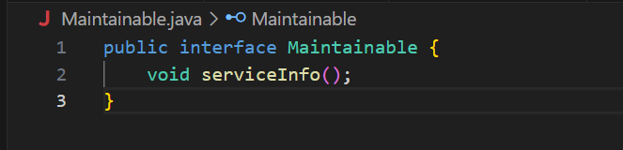

Vehicle.java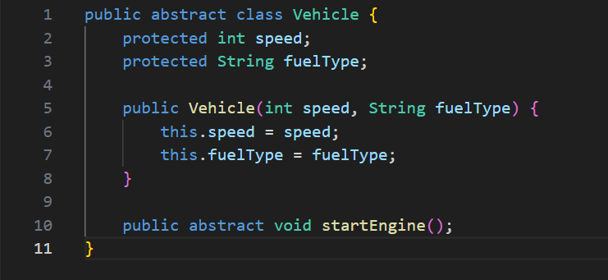

Car.java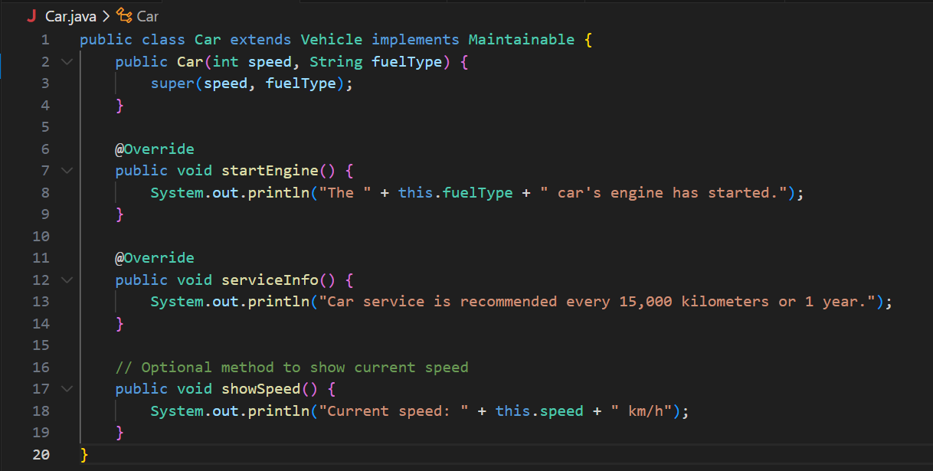

Main.java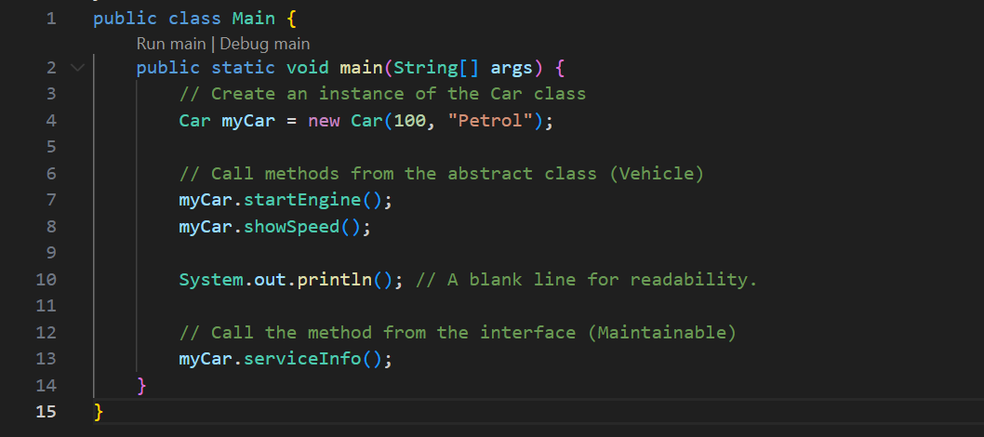

**OUTPUT🡪**

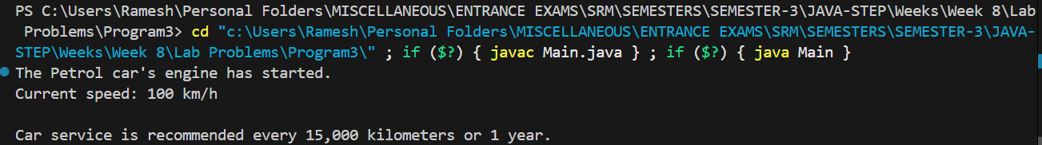

**QNO4🡪**

Create an abstract class Employee with fields name and salary. Add abstract method

calculateBonus().

Create an interface Payable with method generatePaySlip().

Create a class Manager that extends Employee and implements Payable.

Hints:

● Use abstract method for bonus calculation.

● Interface method should handle pay slip generation.

**Payable.java**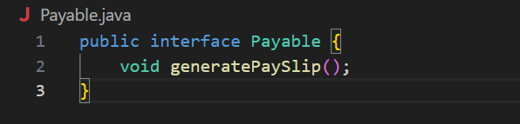

**Employee.java**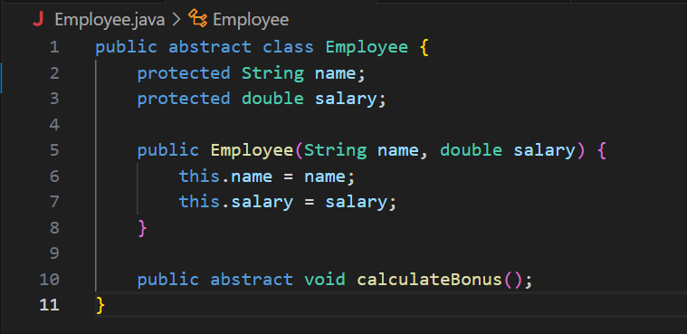

**Manager.java**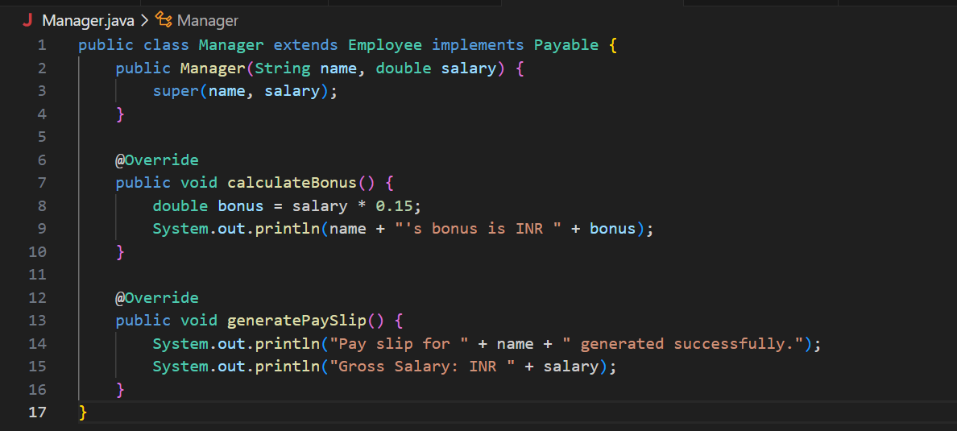

**Main.java**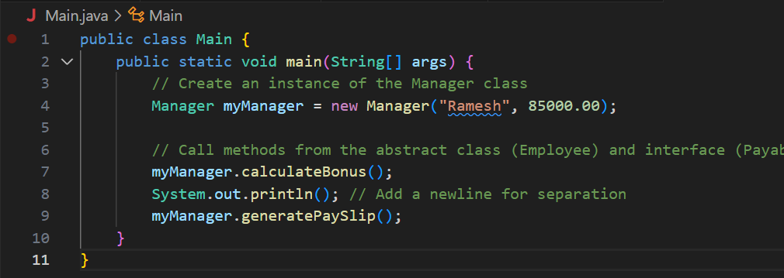

**OUTPUT🡪**

